AI ASSiSTANT LAB ASSIGMENT (12.4)
NAME: Ch srinidh rao
2303A52398
Batch 44
Task 1: Bubble Sort for Ranking Exam
Scores
Scenario
You are working on a college result processing system where a small
list of student scores needs to be sorted after every internal assessment.
Task Description
• Implement Bubble Sort in Python to sort a list of student scores.
• Use an AI tool to:
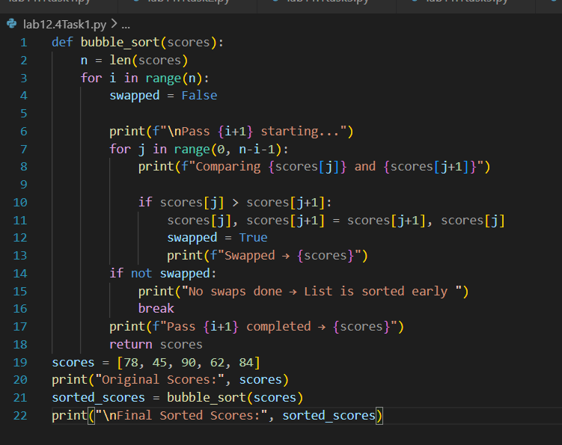
Output:
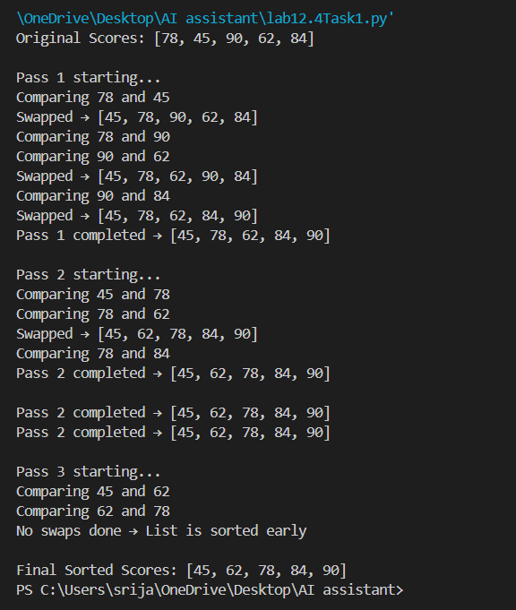
Task 2: Improving Sorting for Nearly Sorted
Attendance Records
Scenario
You are maintaining an attendance system where student roll numbers
are already almost sorted, with only a few late updates.
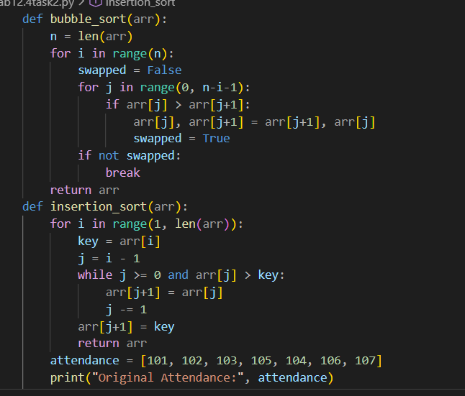

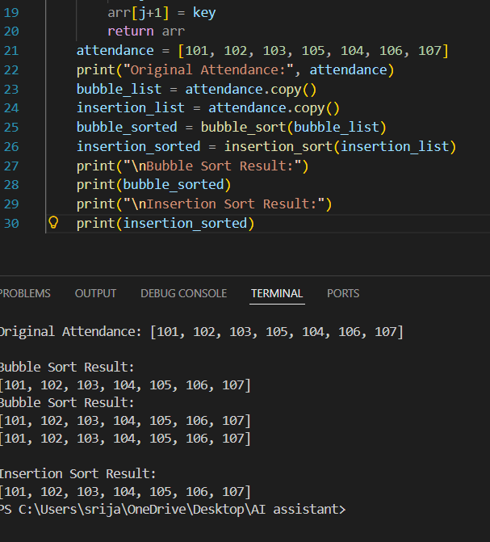
Task 3: Searching Student Records in a
Database
Scenario
You are developing a student information portal where users search for
student records by roll number.
Task Description
• Implement:
o Linear Search for unsorted student data
o Binary Search for sorted student data
• Use AI to:

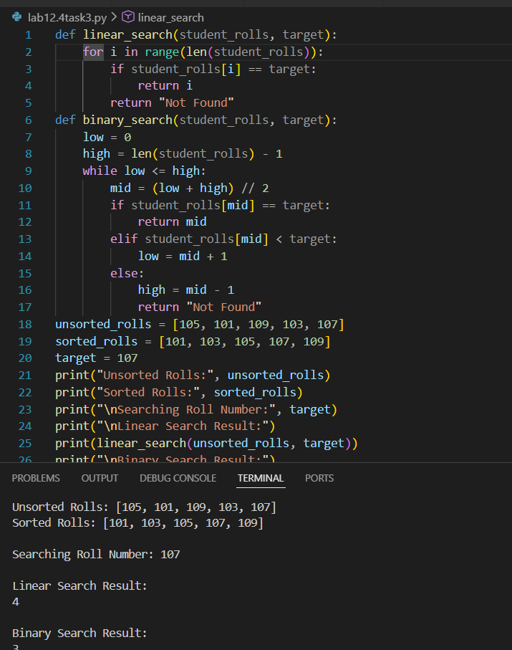
Task 4: Choosing Between Quick Sort and
Merge Sort for Data Processing
Scenario
You are part of a data analytics team that needs to sort large datasets
received from different sources (random order, already sorted, and
reverse sorted).
Task Description
• Provide AI with partially written recursive functions for:
o Quick Sort
o Merge Sort
• Ask AI to:
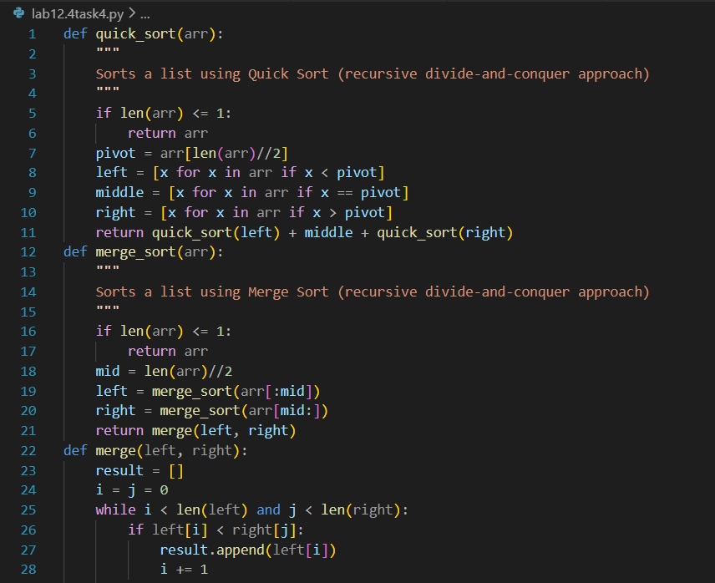
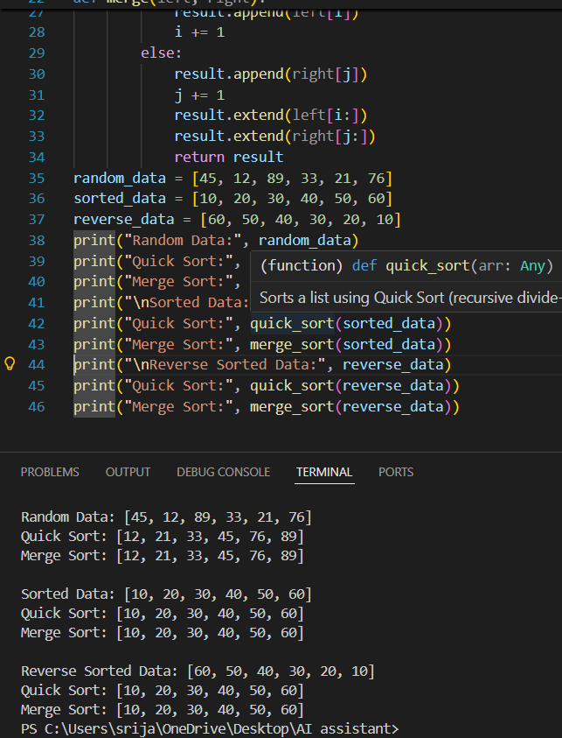
Task 5: Optimizing a Duplicate Detection
Algorithm
Scenario
You are building a data validation module that must detect duplicate
user IDs in a large dataset before importing it into a system.
Task Description
• Write a naive duplicate detection algorithm using nested loops.
• Use AI to:
o Analyze the time complexity
o Suggest an optimized approach using sets or dictionaries
o Rewrite the algorithm with improved efficiency
• Compare execution behavior conceptually for large input sizes
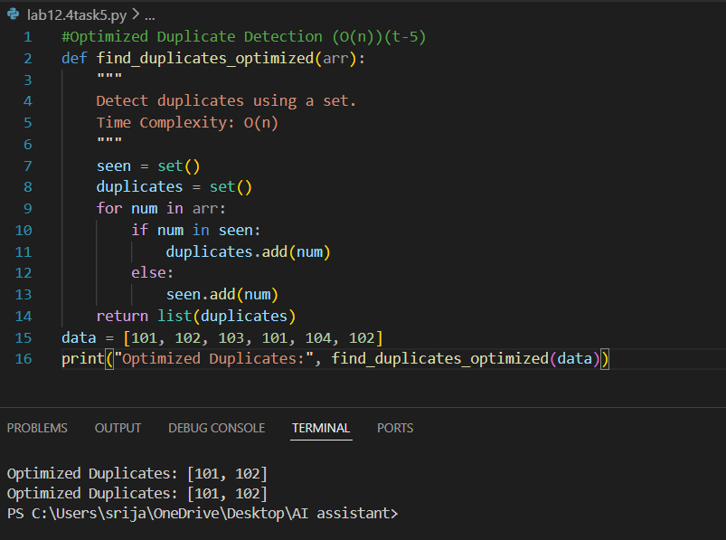
Observation:
Both Quick Sort and Merge Sort correctly sorted random, sorted, and reverse-sorted data. Quick Sort worked faster on random data but may slow down for already sorted or reverse data due to pivot selection. Merge Sort showed consistent performance for all inputs, making it more reliable for structured datasets, though it uses extra memory.

